ANNA SOBETSKA

Tel: +380679337968  E-mail: ansobetska@gmail.com  Facebook: https://www.facebook.com/anna.sobetska  Date of birth: 10.06.1996  Nationality: Ukrainian  Place of residence: Kyiv  Languages: Ukrainian – native;  Russian – native; English – Advanced (C1); German – Pre-Intermediate (B1), French – Beginner (A1). | 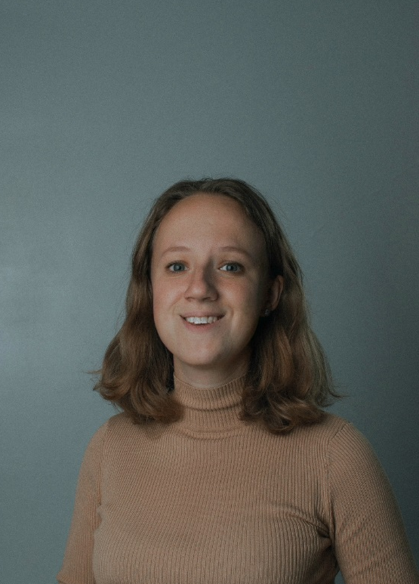

EDUCATION
2016-2020 – Kyiv National Linguistic University (English/German translation);
2018-till now – ProEnglish Theatre and Remarka Film (Acting courses; acting on camera course).

COURSES
- Udemy online course on Social Media Marketing (Certified)
- Coursera online course on Social Media Marketing
- Webinars of 2021 on Social Media Marketing
EXPERIENCE
2016 July – 2016 August – Internship in the Events Department in American Chamber of Commerce
- Performing written translation
- Organization of appointments
- Performing tasks on the project ACC Picnic of United Dreams 2016

2018 – till now – Translator
- Performing written translation of technical documentation from English into Ukrainian and from Ukrainian into English
- Performing revision of English texts

2017 – till now – English Teacher
- Teaching children and adults
- Preparing for the exams

VOLUNTEERING
- Volunteering in English Camps for students
Responsibilities: writing the evening program, hosting talent shows, coordinating students in their preparations for talent shows, holding auditions for students’ performances, transporting the international team to the hotel and airport.
- Volunteering in the Jamm Camp
Responsibilities: reportage photography, editing photos for each day of the camp, preparing a slide show for each day of the camp, uploading the photos to Flickr (around 120 photos for a day).
- Volunteering at the World’s Largest Lesson held by AIESEC
A volunteer at the World’s Largest Lesson which was online. I conducted a lesson which was devoted to Sustainable Development Goals which were instituted in 2015 by the UN.

SKILLS
- Good communication skills and the ability to find a common language with everyone (For two years I have been a volunteer in international English camps for students from different countries (the USA, England, African countries and Ukraine) where I have always been responsible for organizing talent shows and hosting events. While doing this I always help students solve this or that problem, inspire them to participate and help them overcome their fears when they have never been in front of an audience before);
- Good team worker (I am engaged in volunteering and I constantly take part in diverse educational projects. About a month ago I was an AIESEC ambassador during the “World’s largest lesson”);
- Leadership qualities (I went in for professional sports (wushu) for 4 years and became a champion of Ukraine and a world wushu champion in Hong Kong in 2011);
- Quick in decisions (In summer 2019 I travelled around Europe by hitchhiking);
- Good organizational skills (Organization and hosting of various events).
- Proficiency in languages (Ukrainian – native, Russian – fluent, English – fluent (C1), German – good working knowledge (B1), French – basic communication skills (A1), Italian – basic communication skills (A1);
- Good command of MS Office (Word, Exсel, PowerPoint) and other tools like: E-mail, Adobe Lightroom.

